Assignment

1. Explain 5 reasons why emergencies can put people at greater risk of waterborne disease.
2. Increased frequency of intense extreme weather events can cause flooding of water and sewage treatment facilities, increasing the risk of waterborne diseases. Floods can potentially increase the transmission of waterborne diseases, such as typhoid fever, cholera, leptospirosis and hepatitis A and vectorborne diseases, such as malaria, dengue and dengue haemorrhagic fever, chicungunya fever.
3. Droughts can cause increased concentrations of effluent pathogens, overwhelming water treatment plants and contaminating surface water. Thus causing waterborne diseases
4. Changes in ocean and coastal ecosystems, including changes in pH, nutrient and contaminant runoff, salinity, and water security, that can cause degradation of fresh water, particularly in areas where much of the population uses untreated surface water for daily consumption and activities and thus can can put people at greater risk of waterborne disease.
5. Indirectly, the lack of water can cause pressure on agricultural productivity, crop failure, malnutrition, starvation, population displacement, and resource conflict., such conflicts can cause pressure on a resource thus straining it and hence cause scarcity of water resource heralding waterborne disease proliferation Lack of water for washing also puts people’s lives at risk from waterborne illnesses spread by the fecal–oral route.Fecal–oral diseases can proliferate rapidly, sometimes to epidemic proportions, when people in crowded conditions lack clean water for hygiene and sanitation. Among the agents involved are at least 20 viral, bacterial, and protozoan pathogens that cause diseases such as cholera, bacillary dysentery, and the relatively recently discovered hepatitis E.
6. Changes can occur in the distribution and concentrations of chemical contaminants from agricultural farming and practices that are straining the water resources can cause waterborne diseases
7. Sustainability is essential in any project. Substantiate this claim. How is sustainability achieved in donor funded projects? Explain 3 aspects

Sustainability is about integrating economic, environmental and social aspects of the success of a project. This element refers to the triple bottom line or three-P concept as stated by Elkington (1997) and acknowledged by Adams (2006) as the ‘three pillars’ of sustainability: Social, Environmental and Economic (illustrated in [Figure 1](about:reader?url=http%3A%2F%2Fbooks.publishing.monash.edu%2Fapps%2Fbookworm%2Fview%2FThe%2BProject%2Bas%2Ba%2BSocial%2BSystem%253A%2BAsia-Pacific%2BPerspectives%2Bon%2BProject%2BManagement%2F171%2FOEBPS%2Fc11.htm" \l "fig11-1)). The concept suggests that three dimensions are inter-related and therefore may influence each other in multiple ways.

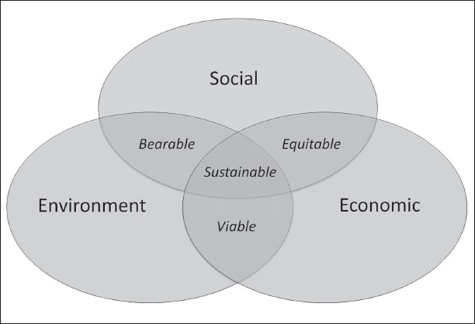

Figure 1The triple-P concept of sustainability

This element focuses attention on the long-term nature of the matter at hand. An important notion in this aspect is that the economic perspective, because of discount rates, tends to value short term effects more than long term effects, whereas social impacts or environmental degradation may not occur before the long-term.

Sustainability is achieved in donor funded projects through the following ways

* **Community involvement:** involving the community is the key to have long term impacts from any projects. Make sure that your project involves the community at various stages, this will give them ownership of the project and there are high chances that they may continue with some project aspects even after the project duration. As the entire process will be participatory the skills and knowledge gained by the present group of people, will be transferable and also replicable.
* **Institutionalize local groups:** Local groups play a very important role in maintaining your program objectives. You can strengthen local institutions like CBOs, YouthGroup etc. and involve them in planning and implementation phase of your project.
* **Community advocacy:** Sensitizing the community about the benefits of a particular project and then initiating a policy advocacy can also ensure sustainability in the long run.
* **Involving local government and departments:** Involvement of local agencies and government will ensure improved access to the government initiatives in this direction. As these agencies are permanent, they will help in sustaining the project activities beyond the project duration.

1. How would you explain what advocacy means to a colleague who is not a WASH worker? Explain the difference between policy advocacy and programme advocacy.

#### Answer

Advocacy refers to building a case in support of a particular cause and or/activity. It is a process that aims to influence decisions within political, economic and social systems and institutional frameworks

Policy advocacy involves trying to influence senior politicians who are responsible for policy setting and aims to get changes in policies and legislation. Programme advocacy is more localized and directed to make changes in the opinions and attitudes of local leaders.

1. Outline four particular challenges involved in urban WASH advocacy.

#### Answer

* Advocacy for increased funding for government-funded urban WASH programmes And Lobbying for multisectoral partnerships for sustainability
* Engaging in and strengthening policy dialogues between communities, civil society groups and decision makers
* Capacity building for Youth groups. CBOs communities, community leaders, networks and local water boards and associations on their rights and responsibilities regarding urban WASH laws, budgets and policies
* Entrenching national and local political leaders on urban WASH

1. What do you understand by community mobilization? Describe briefly how it can be achieved.

**Answer**

Community mobilization is a process through which action is stimulated by a [community](https://en.wikipedia.org/wiki/Community" \o "Community) itself, or by others, that is planned, carried out, and evaluated by a community's individuals, groups, and organizations on a participatory and sustained basis to improve the health, hygiene and education levels so as to enhance the overall [standard of living](https://en.wikipedia.org/wiki/Standard_of_living" \o "Standard of living) in the community This means encouraging and supporting them to act together to achieve desired community goals. .

community mobilization can be achieved through Securing a strong leadership 2. Establishing a formal structure 3. Engaging diverse organizations, community leaders, and residents 4. Ensuring authentic participation and shared decision making 5.ensuring authentic and productive roles for young people 6. Developing a shared vision 7. Conducting a needs assessment 8. Creating a strategic plan 9. Implementing a mutually reinforcing strategies 10. Creating a fundraising strategy 11. Establishing effective channels for internal communication 12. Educating the community 13. Conducting process and outcome evaluations 14. Evaluating the community mobilization effort separately Thus, Communities can be mobilised through helping them to identify their priorities, resources, needs and solutions

b). Explain why knowing your community is essential for effective community mobilization.

Answer

Knowing the community is essential for effective community mobilisation because you need to understand the people in the community and the issues that are important to them.Knowing about language, culture, religion and economic status are also important. It’s important to identify the key stakeholders who have influence of others and who are likely to lead any decision-making process. Facilitators should be familiar with the social structure of the community and the different groups and their leaders. For WASH projects, the current water supply situation, sanitation habits and health status of the community are also essential information.